

CMC Migration AzDo Backlog Creation

3/25/2020

10th Magnitude, LLC
20 North Wacker Drive #530
Chicago, IL 60606

Notice of Confidentiality © 2018 10th Magnitude, LLC All rights reserved

THIS DOCUMENT IS 10TH MAGNITUDE PROPRIETARY AND CONFIDENTIAL INFORMATION AND IS SUBJECT TO THE TERMS OF THE 10TH MAGNITUDE NON-DISCLOSURE AGREEMENT. NEITHER THIS DOCUMENT NOR ITS CONTENTS MAY BE REVEALED OR DISCLOSED TO UNAUTHORIZED PERSONS OR SENT OUTSIDE THE AFOREMENTIONED COMPANY WITHOUT PRIOR PERMISSION FROM 10TH MAGNITUDE.

Backlog Creation Process

- The process should start with the project team submitting a CMC request - either through SharePoint, the ProjectTeam-CMC meeting, or through a message. All details for the items in scope should be filled out in the migration worksheet with planned cutover and replication start dates.

A request can be submitted via SharePoint here: https://10thmagnitude.sharepoint.com/sites/10m-data-center-transformation/SitePages/Submit-a-CMC-Request.aspx

The SharePoint request lands in the CMC DevOps project in the CMC Requests Epic

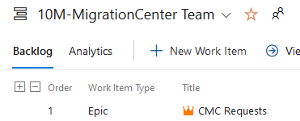

- Grab the info out of the migration worksheet to create the backlog work items for the in scope worksheet items.
  - First, get the workload migration template from the backlog templates folder on SharePoint - https://10thmagnitude.sharepoint.com/sites/10m-data-center-transformation/Shared%20Documents/Forms/AllItems.aspx?viewid=60858a42%2Da69e%2D4770%2Da258%2Dfd3226902cd4&id=%2Fsites%2F10m%2Ddata%2Dcenter%2Dtransformation%2FShared%20Documents%2FProject%20Management%2FBacklog%20Templates

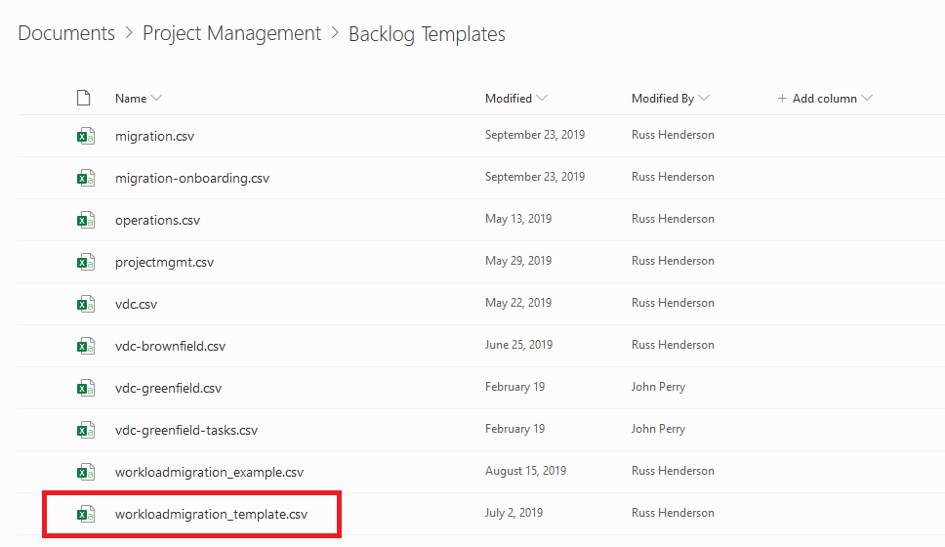

  - Copy and paste the server names, workload names, environment, etc into the workload migration template from the migration worksheet. The migration column must be set to migration, or that row will be skipped. This is useful for working with existing spreadsheets that may have exclusions.
  - Save your file, then copy it into the migration list dropzone folder on SharePoint – make sure to save a copy! The file gets deleted as part of the automated process. https://10thmagnitude.sharepoint.com/sites/10m-data-center-transformation/Shared%20Documents/Forms/AllItems.aspx?viewid=60858a42%2Da69e%2D4770%2Da258%2Dfd3226902cd4&id=%2Fsites%2F10m%2Ddata%2Dcenter%2Dtransformation%2FShared%20Documents%2FProject%20Management%2FMigration%20List%20Dropzone
  - Go to the CMC project backlog and create a workload migration group feature if one doesn’t already exist and note the ID.

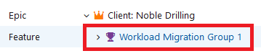

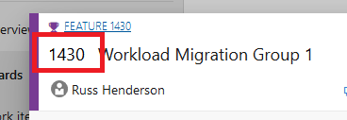

  - Fill out the MS form to create the workload story and server tasks. Make sure that the client name matches any existing tags that are being used in DevOps. https://forms.office.com/Pages/ResponsePage.aspx?id=Z7RgZtOtnk2K2kixchlZ859fz2yLLNxNsqKqQ_SvRVJUNVg5NlkzWk1DTlIxMzg5N0E5VENNSjVGMS4u
  - The form submission kicks off an Azure function app that creates the work items in AzDo. Wait a few minutes for the function to create the requests. You should receive an email on successful completion.
  - Verify that the work items are created and look correct. They should be tagged with the client name. If anything is not correct, you can just delete the incorrect items and use the same process to recreate.

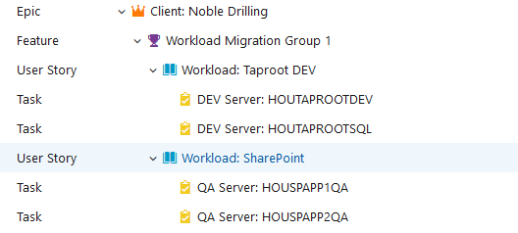

- If a work item was created from the SharePoint request process, move the request into the workload group Epic and close it out so it can be referenced later if needed.

